Task 1: Detective – Code Evidence
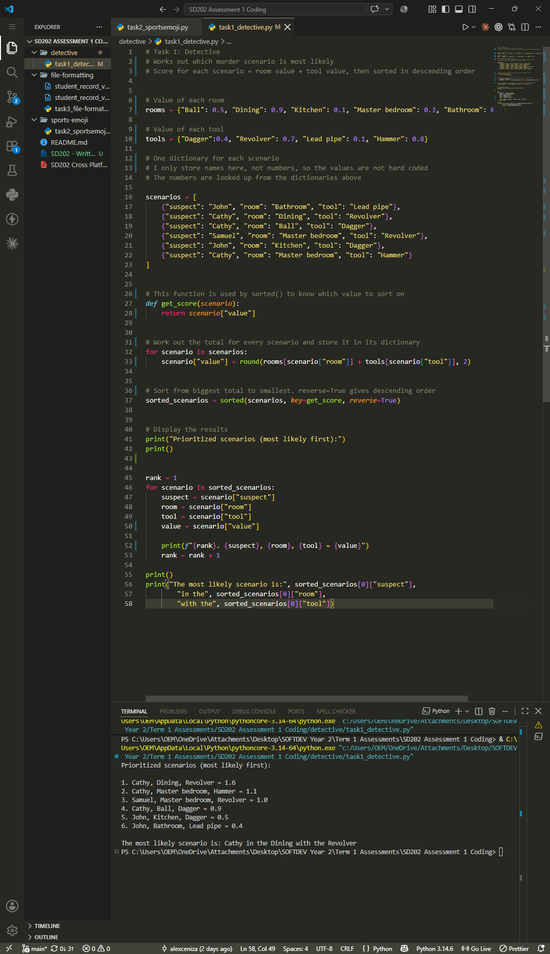

Testing and Debugging:
I ran the code in Visual Studio Code and checked the output against the room and tool values in the assessment table. The six scenarios printed in descending order, with Cathy in the Dining room with the Revolver first at 1.6 (0.9 + 0.7) and John in the Bathroom with the Lead pipe last at 0.4 (0.3 + 0.1). I worked out each total by hand to confirm the lookups were returning the correct values from the rooms and tools dictionaries. I also used round() on the totals so they display to two decimal places, because adding decimals in Python sometimes produces a long result such as 1.7000000000000002.
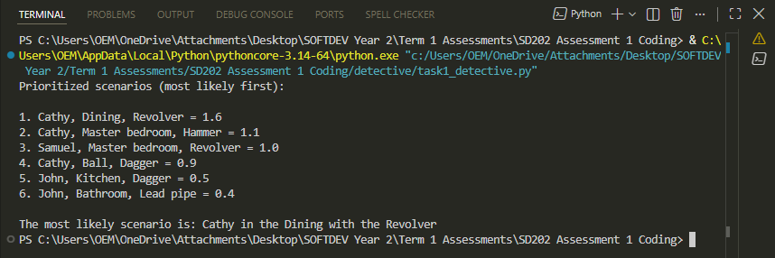

I also tested some other room and tool combinations to check the code would still work if the values changed. With round() taken out, two of these printed long results – 1.7000000000000002 and 0.7999999999999999 – which happens because Python cannot store some decimal numbers exactly. I added round() to the calculation, so the totals always display to two decimals places.

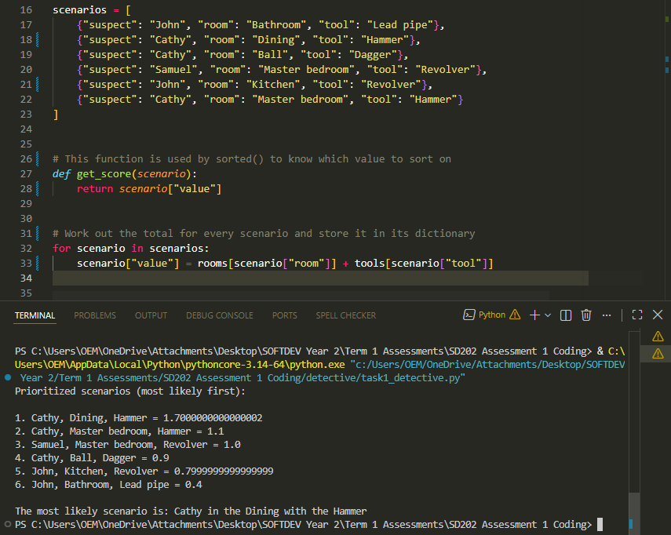

While debugging I found that an earlier version of my code had a separate function to calculate the totals, but I was never calling it because the loop was already doing the same lookups itself. I removed the unused function and renamed my dictionaries to rooms and tools, so that every part of the final program is used and the names are consistent throughout.

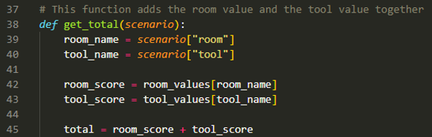

This is an earlier version of the file, before the unused function was removed.
Refer to the full screenshot above or GitHub for final code.

Task 2: Sports Emojis – Code Evidence
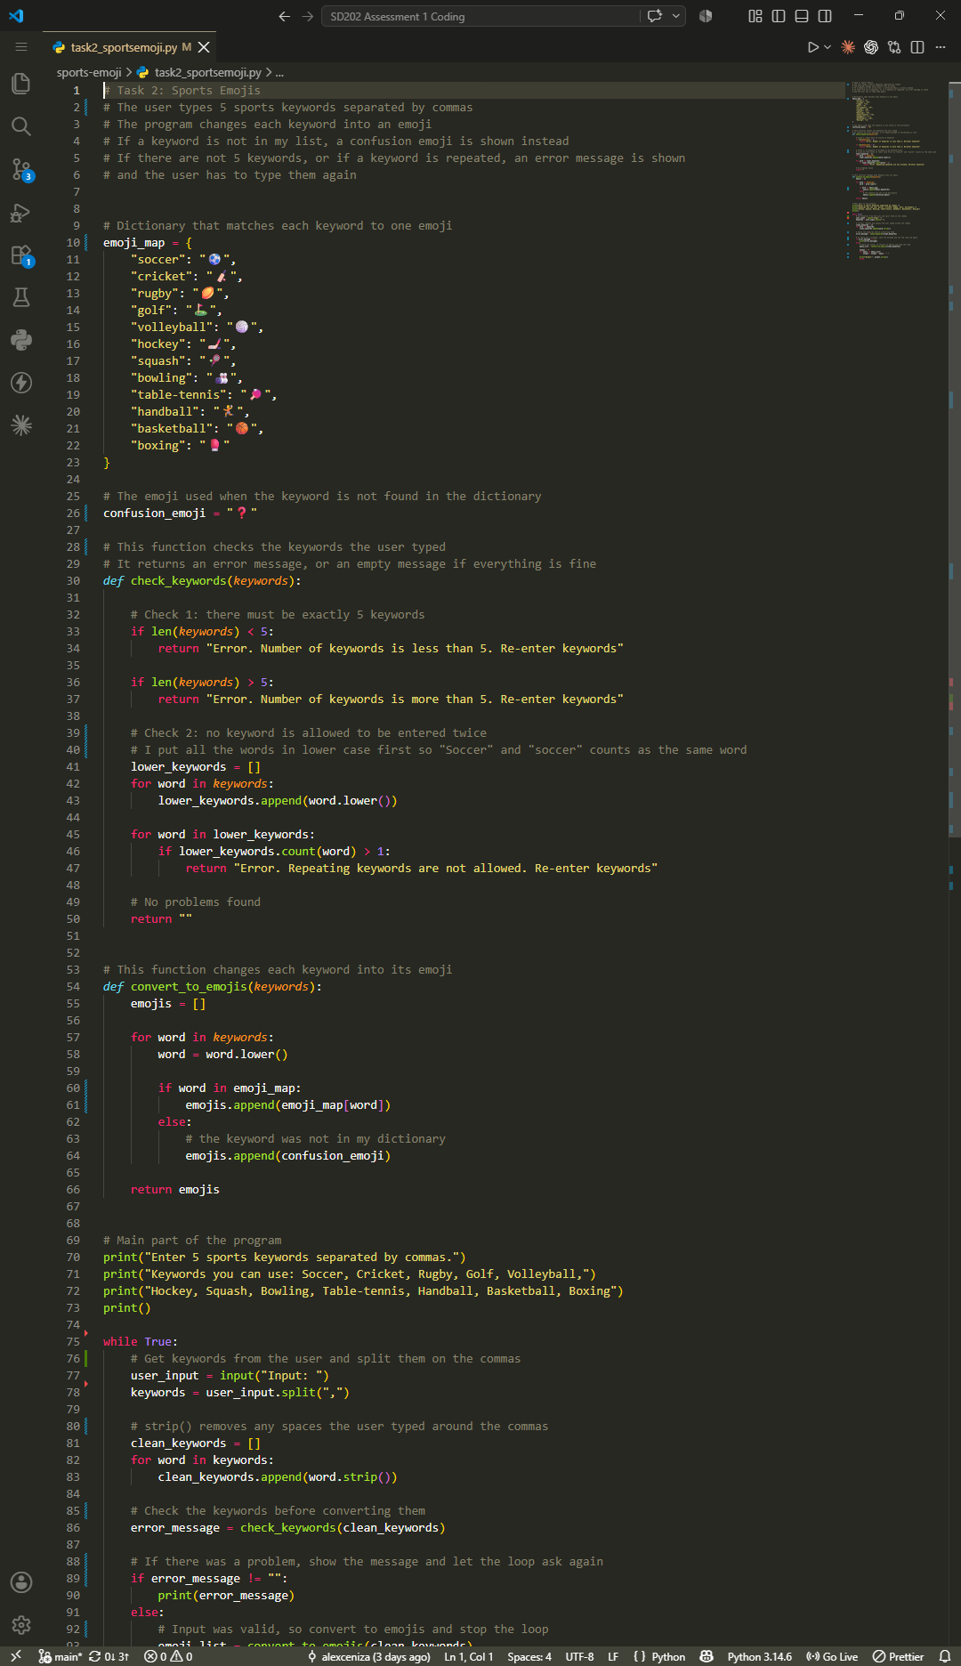

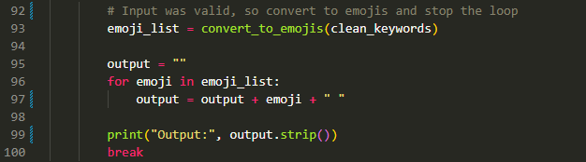

Testing and Debugging:
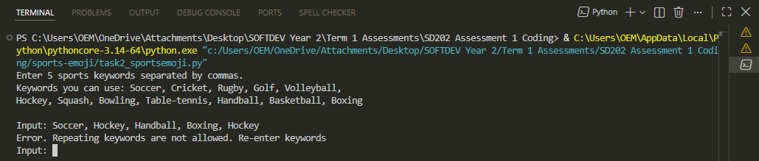
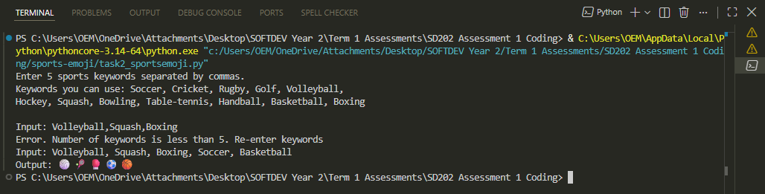
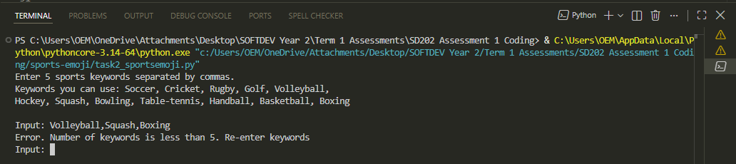
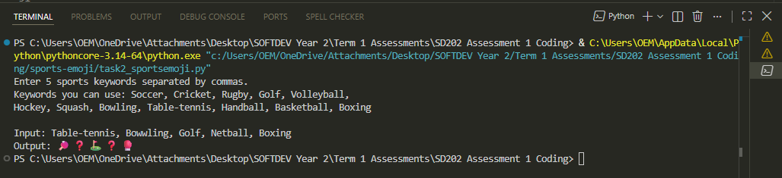
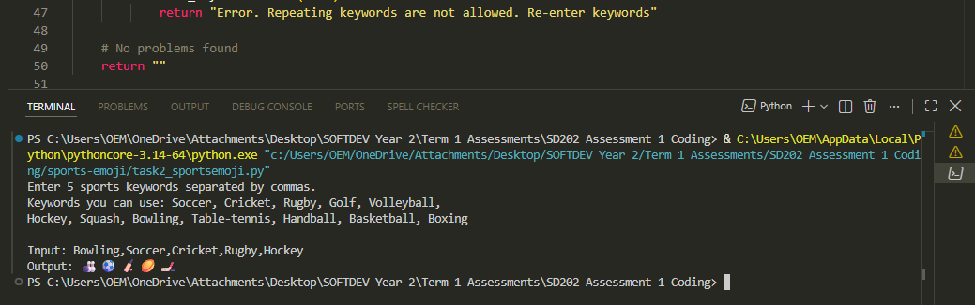
I tested the program using the four sample scenarios from the assessment guideline. The first two converted all five keywords correctly, and in t he second one both “Bowwling” and “Netball” were shown as ❓ because they are not in my dictionary – “Bowwling” is misspelt and “Netball” is not on the list of keywords. The third and fourth scenarios produced the expected error messages. For each one I first captured the empty Input prompt to show the loop waiting for the keywords again, then entered a valid set to show it completing.

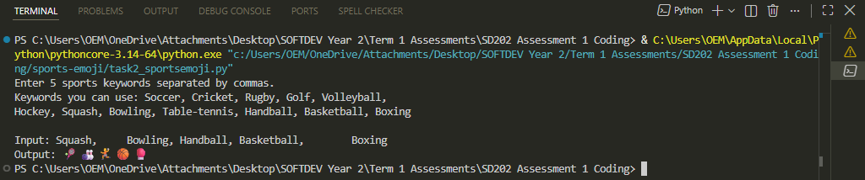
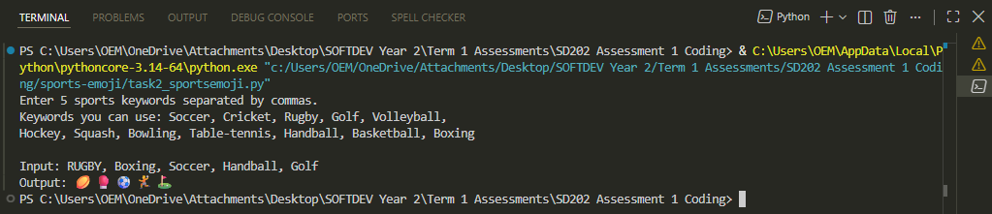
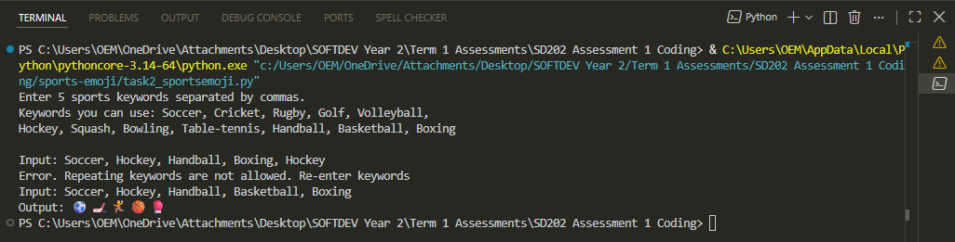
I also tested some input of my own. Typing keywords in different cases such as "RUGBY" still worked, because I converted each word to lower case before looking it up. Entering extra spaces around the commas also worked, because strip() removes them from each keyword before they are checked. While testing I noticed the output had an extra space at the end, so I used strip() on the final output.

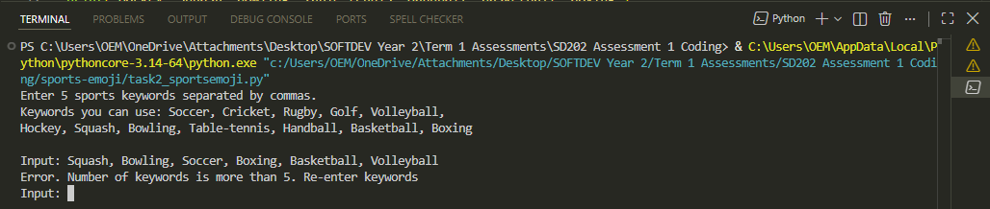
I also tested more than 5 keywords to check the check_keywords() function. The program showed the matching error message and returned to an empty Input prompt for the keywords to be entered again.

Refer to the full screenshot above or GitHub for final code.

Task 3: File Formatting – Code Evidence
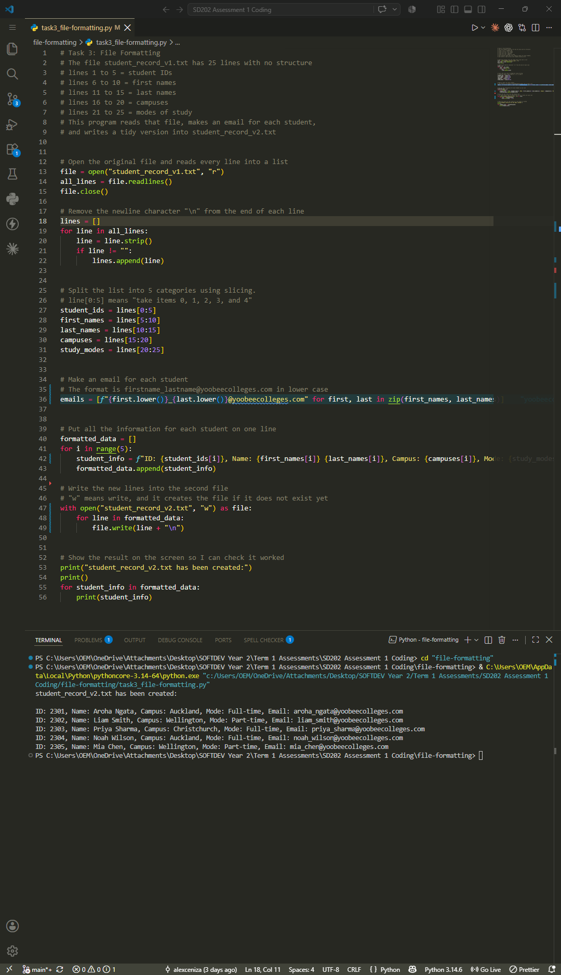

Testing and Debugging:
I ran the program and it created student_record_v2.txt with one line for each of the five students. I opened the new file in Visual Studio Code and in File Explorer to confirm it had been written to disk, then checked it against student_record_v1.txt to make sure the slicing had put each value in the right category. For example, student 20241001 has the first name from line 6, the last name from line 11, the campus from line 16 and the mode from line 21 of the original file.
While checking the output I noticed one of the emails had a space in it, because the first name on line 6 is two words. An email address cannot contain a space, so I used replace() to remove any spaces when building the email, which changed it to alisuper_lane@yobeecolleges.com.
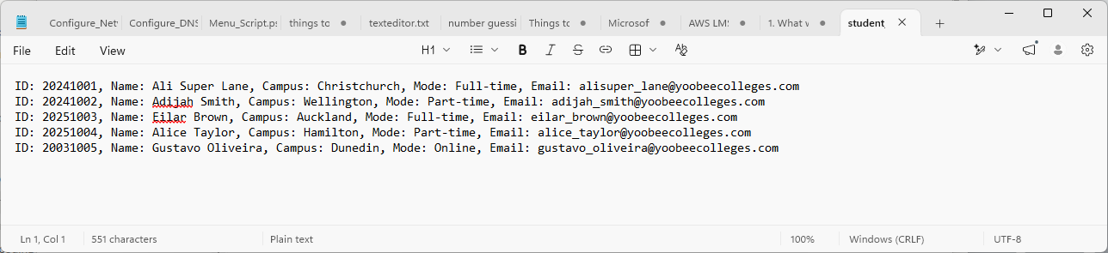

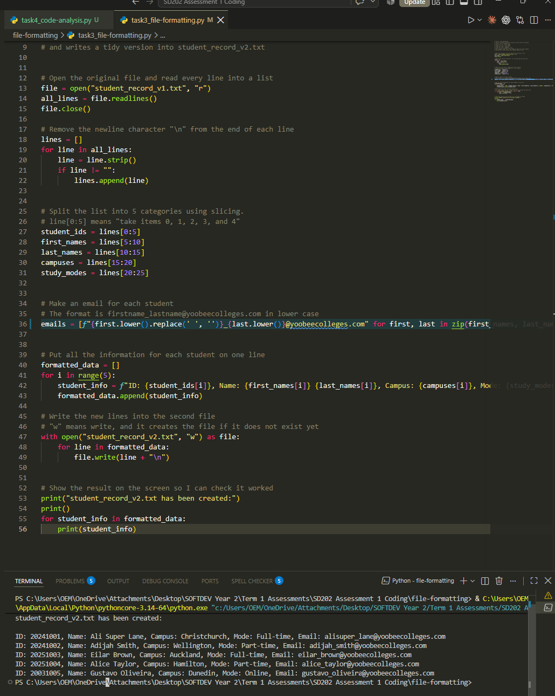

While testing the program I got a FileNotFoundError. The message showed the program could not find student_record_v1.txt, even though the file was in the same folder as my script. The problem was that the terminal was running from the parent folder, so the program was looking for the file in the wrong place. I used cd to move into the file-formatting folder and the program then found the file and ran correctly.
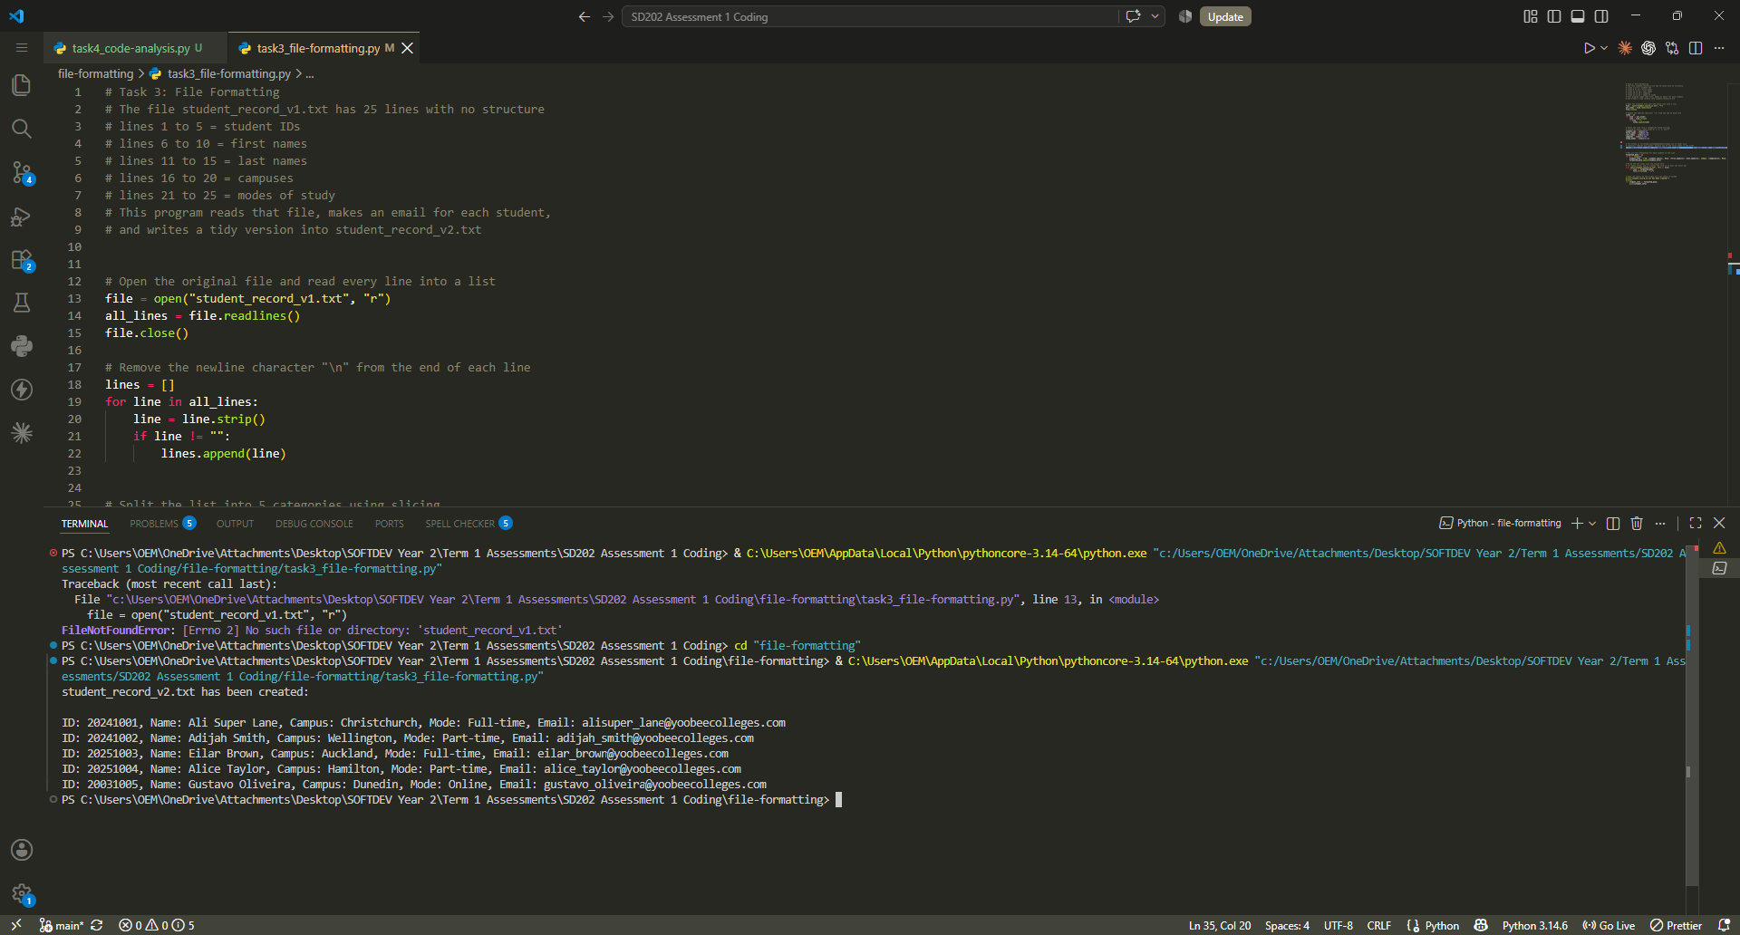
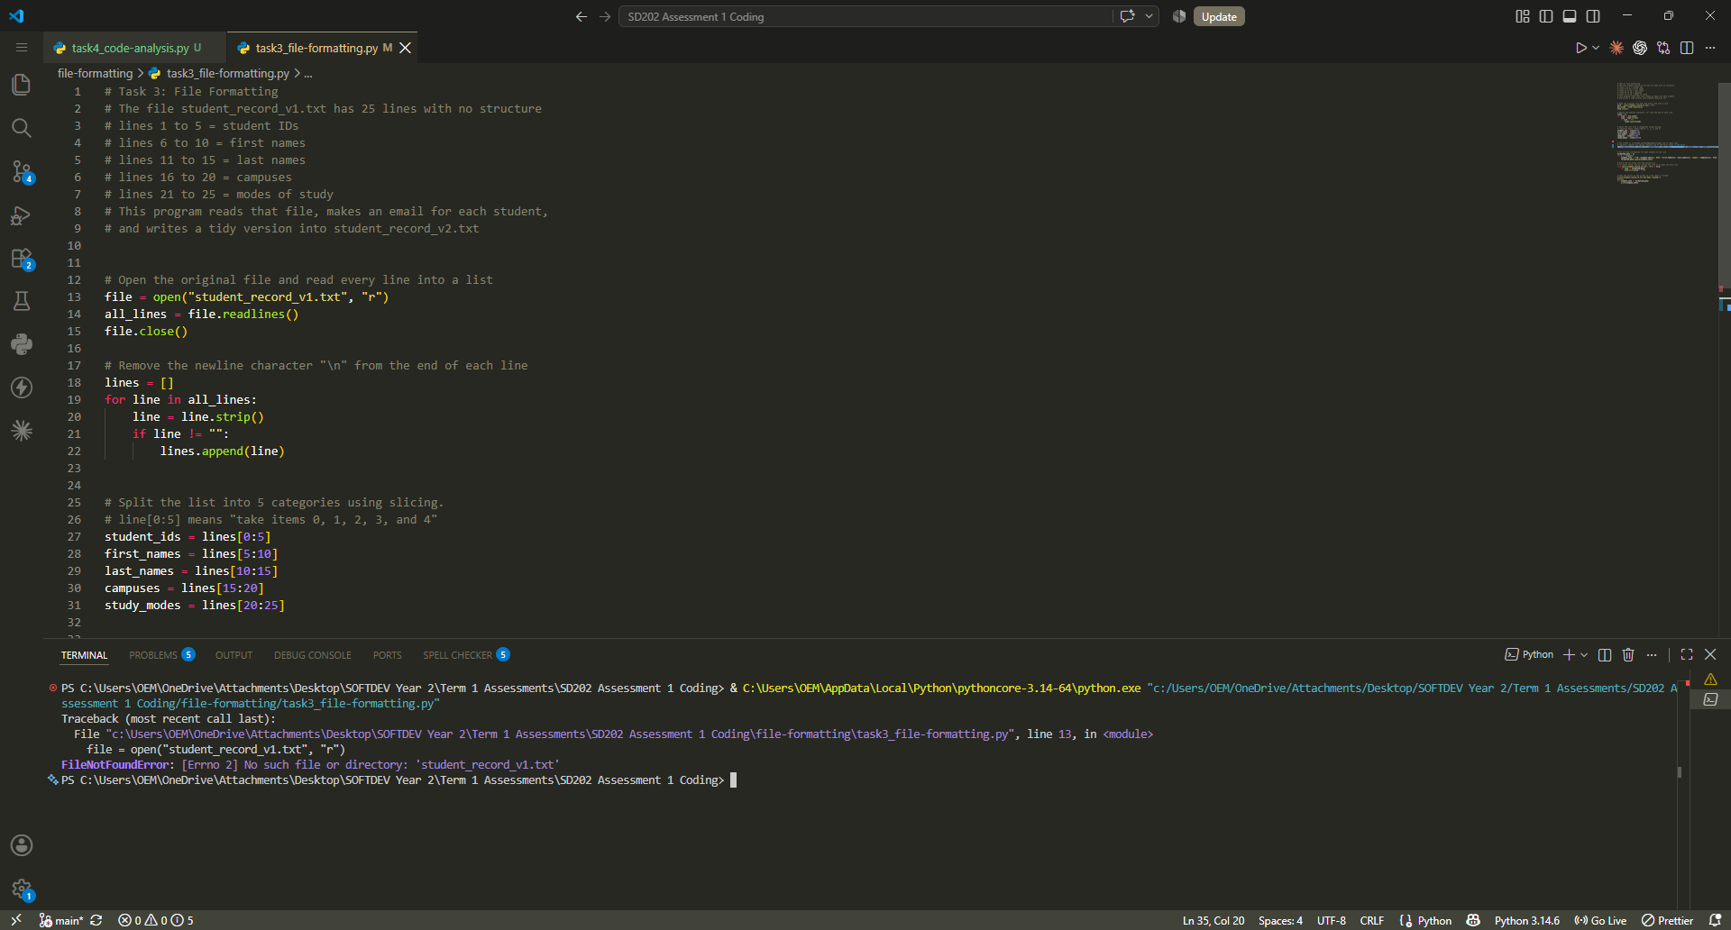

Task 4: Code Analysis
1. Purpose of the code
This program compares two lists of numbers. It takes two lists, s1 and s2, works out the average of each one, and then works out how far apart the two lists are. It prints three lines: the mean of the first list, the mean of the second list, and a distance value.
The problem it solves is measuring how similar two lists are. If the numbers are close together the distance is small, and if they are far apart the distance is large.
The code has three functions at the top, then an example section that makes the two lists and calls the functions. It checks the two lists are the same length first and only does the calculations if that check passes. If it fails, it prints a warning instead.
2. Function analysis
sequnece_checker(s1, s2)
Takes two lists as parameters. It compares the length of the first list with the length of the second. If the lengths are different it returns False, otherwise it returns True. This works as a safety check, because the distance calculation compares the lists position by position and would break if one list was shorter. I also noticed the function name is misspelt — it should be sequence_checker. It does not cause an error because the same misspelling is used when the function is called, but it is still a mistake in the code.
calculate_mean(anysequence)
Takes one list as a parameter. It sets total and count to zero, then goes through every number in the list, adding the number to total and adding one to count. It returns total / count, which is the average. This gives one value that describes each list, so the two lists can be summarised as well as compared.
distance_fn(s1, s2)
Takes two lists as parameters. It sets squared_diff_sum to zero, then goes through each position in the lists. At each position it takes the second value away from the first, squares the answer, and adds it to the running total. It returns that total. This is the main measurement in the program. It is worth noting that it returns the squared distance, because there is no square root at the end, so it is not the full Euclidean distance formula.
3. Error analysis
When I ran the code as it was given, it did not produce an error. Both lists have five values, so sequnece_checker returned True and the program printed the mean of sequence 1 as 4.2, the mean of sequence 2 as 8.0, and the distance as 83.

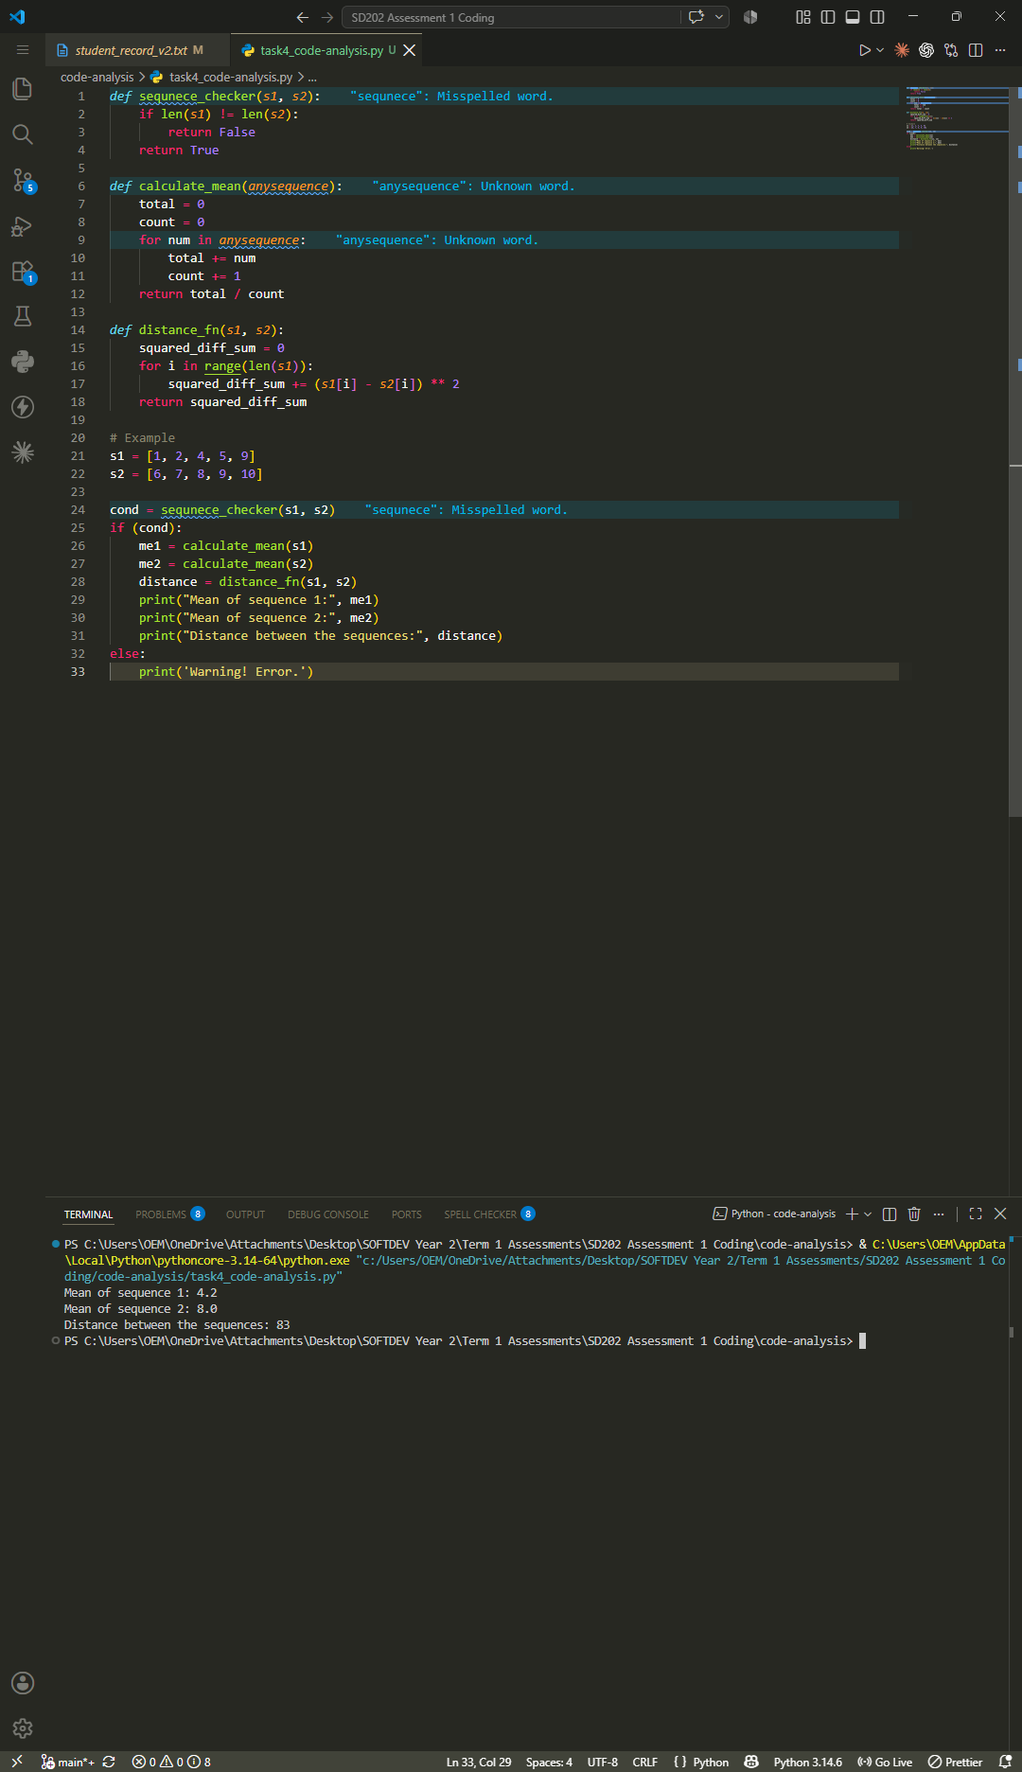

To find the errors the code can produce, I tested it with different inputs.
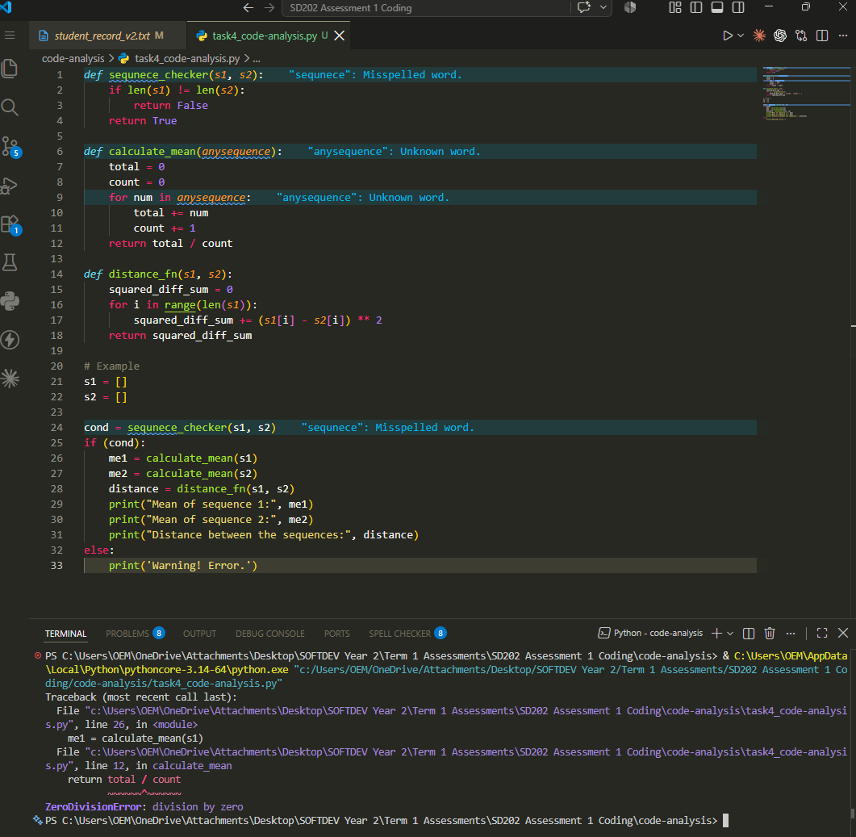
ZeroDivisionError. When I used two empty lists, the program crashed with ZeroDivisionError: division by zero. This comes from the last line of calculate_mean, which returns total / count. If the list is empty the loop never runs, so count stays at zero and the program tries to divide by zero. It happens because sequnece_checker only compares the two lengths against each other. Two empty lists have the same length, so the check passes even though there is nothing to calculate.

TypeError. When I put a string into one of the lists, the program crashed with TypeError: unsupported operand type(s) for +=: 'int' and 'str'. This comes from the line total += num inside calculate_mean. It happens because the code assumes every item is a number, and Python cannot add a string to an integer.
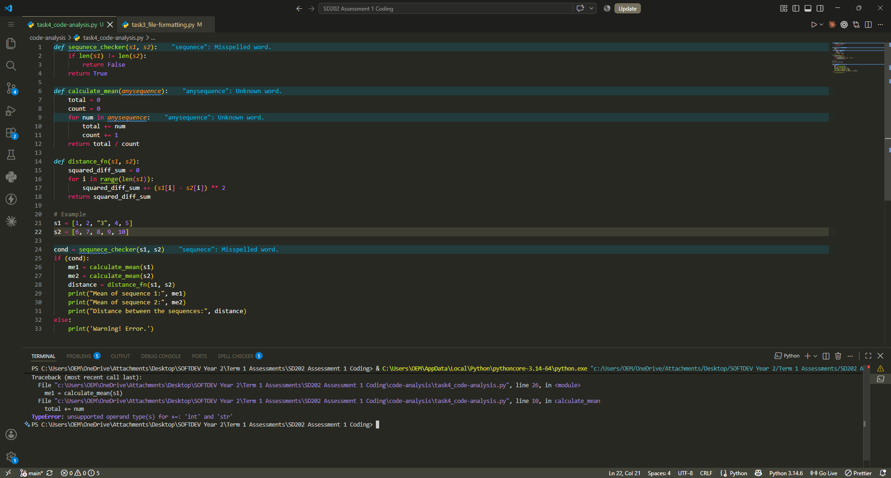

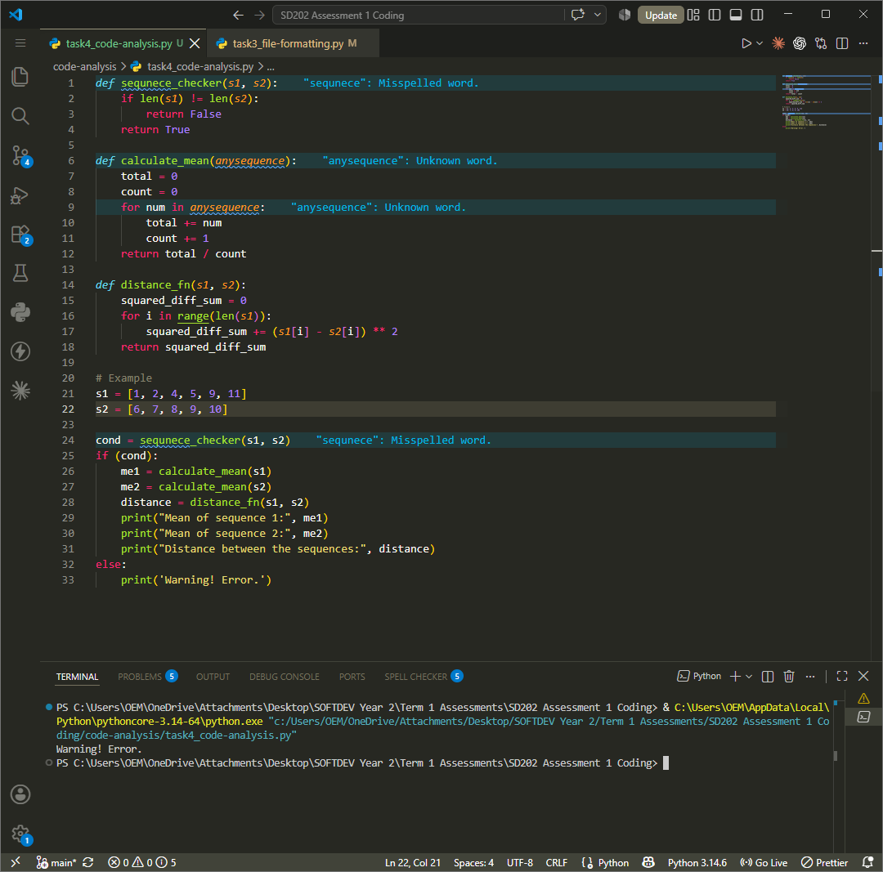
Handled case. When I gave the two lists different lengths, the program did not crash. sequnece_checker returned False, so the else branch ran and printed Warning! Error. This is not a Python error, it is the program's own message. Without this check the program would crash with an IndexError in distance_fn, because the loop uses the length of s1 to index into s2.

4. Code modification analysis
The expression (s1[i] - s2[i]) ** 2 finds the difference between two values in the same position and then squares it. Squaring does two things: it makes the answer positive no matter which value is bigger, and it gives more weight to bigger differences.
If this is changed to (s1[i] - s2[i]), the differences are added up without being squared. Using the example lists, the result changes from 83 to −19.
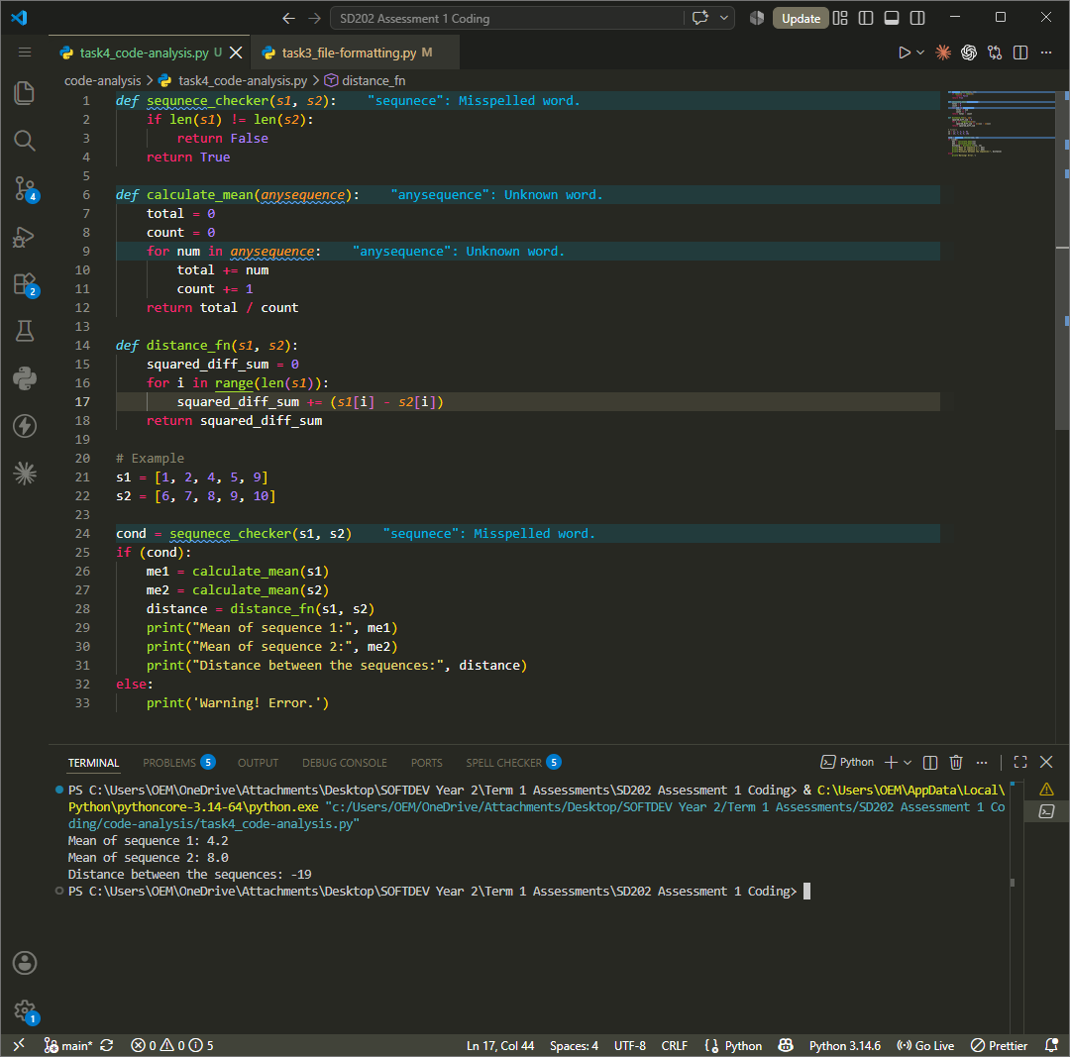
This breaks the result as a distance in three ways.

The answer can be negative. A distance cannot be less than zero, so −19 is not a meaningful distance.
The answer is no longer the same both ways round. Comparing [1, 2, 3] to [4, 5, 6] gives −9, but comparing [4, 5, 6] to [1, 2, 3] gives +9. The distance between two lists should be the same whichever order you compare them in.
Positive and negative differences cancel each other out. Comparing [0, 10] to [10, 0] gives 0 without the squaring, which suggests the two lists are the same when they are actually opposites. With the squaring the same comparison gives 200.
There is also a mathematical result. Without the squaring, adding up all the differences is the same as the number of items multiplied by the difference between the two means. For the example lists this is 5 × (4.2 − 8.0) = −19, which matches exactly. So, the function stops measuring distance and just becomes the difference between the two means, scaled up. The program already works that out using calculate_mean, so the function would be doing the same job twice and would no longer help with comparing the lists.

